**1. TCP Server Code (server1.c and server2.c)**

Each server will listen for a connection and either return the CPU load or perform the string conversion.

#include <stdio.h>

#include <string.h>

#include <stdlib.h>

#include <unistd.h>

#include <arpa/inet.h>

#include <ctype.h>

#define PORT 12345 // Use a different port for server2 (e.g., 12346)

#define BUFFER_SIZE 1024

// Function to calculate CPU usage (dummy value for simplicity)

float get_cpu_load() {

return (rand() % 100) / 100.0; // Return a random CPU usage between 0 and 1

}

// Function to convert a string to uppercase

void to_uppercase(char *str) {

for (int i = 0; str[i]; i++) {

str[i] = toupper(str[i]);

}

}

int main() {

int server_socket, client_socket;

struct sockaddr_in server_addr, client_addr;

char buffer[BUFFER_SIZE];

socklen_t addr_len;

// Create socket

server_socket = socket(AF_INET, SOCK_STREAM, 0);

server_addr.sin_family = AF_INET;

server_addr.sin_port = htons(PORT);

server_addr.sin_addr.s_addr = INADDR_ANY;

// Bind the socket to an address

bind(server_socket, (struct sockaddr *)&server_addr, sizeof(server_addr));

// Start listening for connections

listen(server_socket, 5);

printf("Server listening on port %d...\n", PORT);

while (1) {

addr_len = sizeof(client_addr);

client_socket = accept(server_socket, (struct sockaddr *)&client_addr, &addr_len);

printf("Accepted connection from load balancer...\n");

// Receive command (either "CPU" for load or string for conversion)

recv(client_socket, buffer, BUFFER_SIZE, 0);

buffer[strlen(buffer)] = '\0'; // Ensure null termination

if (strcmp(buffer, "CPU") == 0) {

// Send CPU load

float cpu_load = get_cpu_load();

send(client_socket, &cpu_load, sizeof(cpu_load), 0);

printf("Sent CPU load: %.2f\n", cpu_load);

} else {

// Convert string to uppercase

to_uppercase(buffer);

send(client_socket, buffer, strlen(buffer), 0);

printf("Sent uppercase string: %s\n", buffer);

}

close(client_socket);

}

close(server_socket);

return 0;

}

Output:

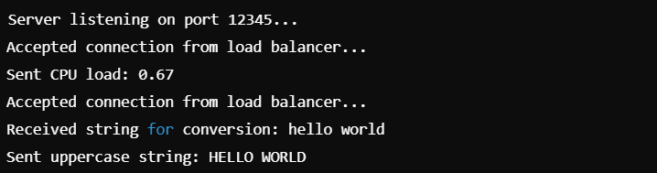

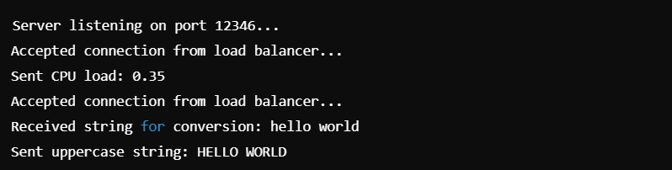

**2. Load Balancer Code (broker.c)**

The load balancer will handle client requests, compare the CPU usage of the two servers, forward the string to the least-loaded server, and return the result to the client.

#include <stdio.h>

#include <string.h>

#include <stdlib.h>

#include <unistd.h>

#include <arpa/inet.h>

#define SERVER1_PORT 12345

#define SERVER2_PORT 12346

#define BUFFER_SIZE 1024

// Function to query CPU load from a server

float get_cpu_load(int port) {

int sock;

struct sockaddr_in server_addr;

float cpu_load;

// Create socket

sock = socket(AF_INET, SOCK_STREAM, 0);

server_addr.sin_family = AF_INET;

server_addr.sin_port = htons(port);

server_addr.sin_addr.s_addr = inet_addr("127.0.0.1");

// Connect to the server

connect(sock, (struct sockaddr *)&server_addr, sizeof(server_addr));

// Send "CPU" request to get CPU load

send(sock, "CPU", 3, 0);

recv(sock, &cpu_load, sizeof(cpu_load), 0);

close(sock);

return cpu_load;

}

// Function to send a string to a server for conversion

void send_string_to_server(int port, char *str, char *result) {

int sock;

struct sockaddr_in server_addr;

// Create socket

sock = socket(AF_INET, SOCK_STREAM, 0);

server_addr.sin_family = AF_INET;

server_addr.sin_port = htons(port);

server_addr.sin_addr.s_addr = inet_addr("127.0.0.1");

// Connect to the server

connect(sock, (struct sockaddr *)&server_addr, sizeof(server_addr));

// Send the string for conversion

send(sock, str, strlen(str), 0);

recv(sock, result, BUFFER_SIZE, 0);

close(sock);

}

int main() {

int broker_socket, client_socket;

struct sockaddr_in broker_addr, client_addr;

char buffer[BUFFER_SIZE], result[BUFFER_SIZE];

socklen_t addr_len;

// Create socket for load balancer

broker_socket = socket(AF_INET, SOCK_STREAM, 0);

broker_addr.sin_family = AF_INET;

broker_addr.sin_port = htons(12347); // Broker server port

broker_addr.sin_addr.s_addr = INADDR_ANY;

// Bind the socket

bind(broker_socket, (struct sockaddr *)&broker_addr, sizeof(broker_addr));

listen(broker_socket, 5);

printf("Load Balancer listening on port 12347...\n");

while (1) {

addr_len = sizeof(client_addr);

client_socket = accept(broker_socket, (struct sockaddr *)&client_addr, &addr_len);

printf("Accepted connection from client...\n");

// Receive string from the client

recv(client_socket, buffer, BUFFER_SIZE, 0);

buffer[strlen(buffer)] = '\0'; // Ensure null termination

// Get CPU loads from both servers

float cpu1 = get_cpu_load(SERVER1_PORT);

float cpu2 = get_cpu_load(SERVER2_PORT);

printf("CPU load - Server 1: %.2f, Server 2: %.2f\n", cpu1, cpu2);

// Send the string to the server with the lower CPU load

if (cpu1 < cpu2) {

send_string_to_server(SERVER1_PORT, buffer, result);

} else {

send_string_to_server(SERVER2_PORT, buffer, result);

}

// Send the result back to the client

send(client_socket, result, strlen(result), 0);

printf("Sent result back to client: %s\n", result);

close(client_socket);

}

close(broker_socket);

return 0;

}

Output:

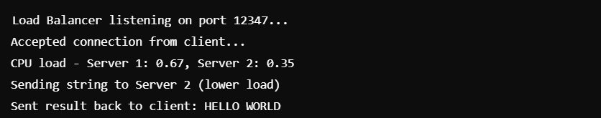

**3. Client Code (client.c)**

The client sends a string to the load balancer and receives the converted string back.

#include <stdio.h>

#include <string.h>

#include <stdlib.h>

#include <unistd.h>

#include <arpa/inet.h>

#define BROKER_PORT 12347

#define BUFFER_SIZE 1024

int main() {

int sock;

struct sockaddr_in broker_addr;

char buffer[BUFFER_SIZE], result[BUFFER_SIZE];

// Create socket

sock = socket(AF_INET, SOCK_STREAM, 0);

broker_addr.sin_family = AF_INET;

broker_addr.sin_port = htons(BROKER_PORT);

broker_addr.sin_addr.s_addr = inet_addr("127.0.0.1");

// Connect to load balancer

connect(sock, (struct sockaddr *)&broker_addr, sizeof(broker_addr));

// Input string to send

printf("Enter a string to convert: ");

fgets(buffer, BUFFER_SIZE, stdin);

buffer[strlen(buffer) - 1] = '\0'; // Remove newline

// Send string to load balancer

send(sock, buffer, strlen(buffer), 0);

// Receive the uppercase string

recv(sock, result, BUFFER_SIZE, 0);

printf("Received uppercase string: %s\n", result);

close(sock);

return 0;

}

Output:

